**IOT ASSIGNMENT-4**

BY P.POOJA SREE

19R11A04H8

**Code:-**

int echopin=4;

int trigpin=5;

int led=2;

#include "BluetoothSerial.h"

BluetoothSerial SerialBT;

void setup() {

pinMode(echopin,INPUT);

pinMode(trigpin,OUTPUT);

pinMode(led,OUTPUT);

Serial.begin(115200);

delay(2000);

Serial.println("data");

SerialBT.begin("ESP32test"); //Bluetooth device name

Serial.println("The device has started, now you can pair it with bluetooth!");

}

void loop() {

int Data= (SerialBT.read());

digitalWrite(trigpin,HIGH);

delay(1000);

digitalWrite(trigpin,LOW);

int duration=pulseIn(echopin,HIGH);

int distance=duration*0.0343/2;

//Serial.print("the distance is..");

//Serial.println(distance);

delay(3000);

if (distance<154)

{

Serial.print("the distance is..");

Serial.println(distance);

Serial.println("water level is full, pump is to be switched off");

SerialBT.print("water level is..");

SerialBT.println(distance);

digitalWrite(led,LOW);

Serial.write(SerialBT.read());//(0=pump off)

delay(1000);

}

else

{

Serial.print("the distance is..");

Serial.println(distance);

Serial.println("water level is low, pump is to be switched on");

SerialBT.print("water level is..");

SerialBT.println(distance);

digitalWrite(led,HIGH);

Serial.write(SerialBT.read());//(1=pump on)

delay(1000);

}

delay(20);

}

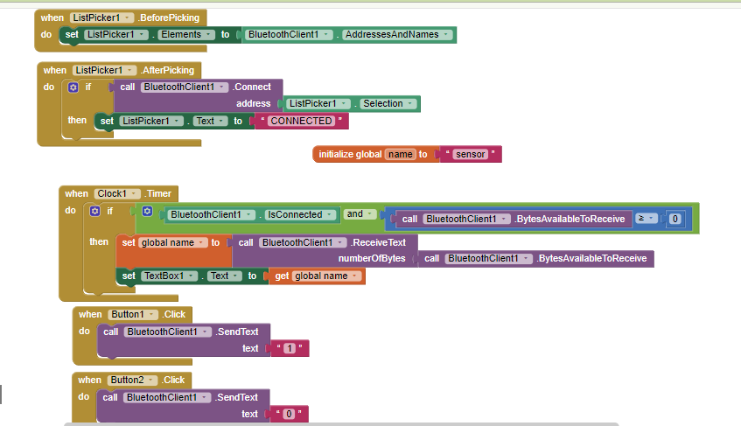

**Serial monitor readings:-**

the distance is..2337

water level is low, pump is to be switched on

0the distance is..2355

water level is low, pump is to be switched on

the distance is..2355

water level is low, pump is to be switched on

1

the distance is..9

water level is full, pump is to be switched off

the distance is..13

water level is full, pump is to be switched off

0

the distance is..244

water level is low, pump is to be switched on

1

the distance is..245

